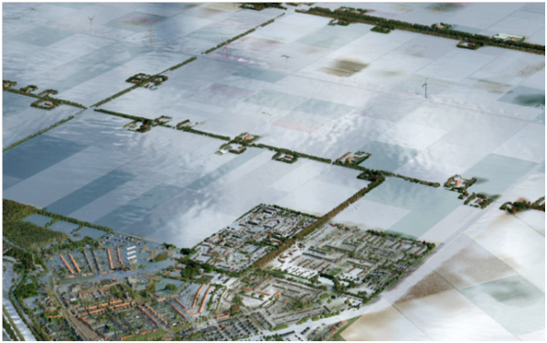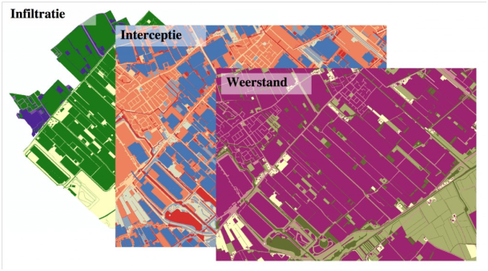



**Description modelling tool 3Di**

Working steps for modelling

**Description modelling tool**

**3Di**

Working steps for modelling

**For**

Name client

Address client

City name client

**Nelen & Schuurmans**

Postbus 1219

3500 BE Utrecht

www.nelen-schuurmans.nl

**Project details**

Dossier : Case number

Date : 25-10-2013

No part of this publication may be reproduced or be made public by means of a print, photocopy, microfilm or in any other possible manner whatsoever without prior permission of the publisher. Nor can it be used for any other work than for which it is manufactured without such permission.

Content

1 Introduction 5

1.1 Vision 5

1.2 User manual 5

2 Basic principles 6

2.1 Horizontal calculation method 6

2.1.1 Subgrids 6

2.1.2 The calculation grid 7

2.1.3 Surface runoff 7

2.1.4 Groundwater Flow 8

2.2 Vertical calculation method 8

2.3 1D-elements 9

2.3.1 1D Channel 9

2.3.2 Constructions (Kunstwerken) 10

2.3.3 Levees 10

3 Modeling with 3Di 11

3.1 Collecting data 11

3.1.1 Base schematisation 11

3.1.2 Model schematisations 12

3.2 Designing the model 12

3.2.1 The mdu file 13

3.2.2 Elevation grid and calculation grid, the basis of every model 13

3.2.3 Flood model 14

3.2.4 Flooding model polder 16

3.2.5 Urban flooding model 19

3.3 Calculating 20

4 Model components 22

4.1 Table overview MDU 22

4.2 Grids 22

4.3 Calculation grid 22

4.3.1 Automatically defined grid 22

4.3.2 Dike-file 23

4.4 Model options 24

4.4.1 Teta 24

4.4.2 OpenLinkCheck 24

4.4.3 Flooding Threshold 27

4.4.4 Advection 27

4.4.5 Output 27

4.5 Initialisation 27

4.6 Manholes 27

4.7 Levee – LeveeFile 28

4.8 1D-Network – NetworkFile 30

4.9 1D Constructions -Structures 35

4.9.1 Weir 35

4.9.2 Pumping station 36

4.10 Sewage system 36

4.11 External Forcing 36

4.11.1 2D-external forcing 36

4.11.2 1D-external forcing 40

4.11.3 Precipitation 42

4.12 Ground water 43

4.12.1 Calculations vadose zone 43

# 1 Introduction

## 1.1 Vision

3Di is an integral calculation model for water safety and water management which can be used for 1D and 2D calculations. It is developed by a consortium consisting of members from Deltares, TU Delft and Nelen en Schuurmans. With 3Di it is possible to calculate faster and on a bigger level of detail than with other existing models, even for a large area. This makes the 3Di model also suitable for online applications. Because results are being showed even during calculation one can see if the model diagram is correct. This makes it possible to work in a quick and efficient way.

The model can be used for rainfall-runoff modelling, flooding calculations and groundwater modelling. As a result issues related to multilayer safety, risks of flooding and analysing regional and urban water logging can be dealt with.

## 1.2 User manual

This document will help the novice as well as the experienced 3Di user. For the beginner it contains background information and key points for creating a first model, while for the experienced user this will serve as a desk book.

In chapter 2 the principles and calculation method that 3Di uses will be explained. These are important for the choices the modeller makes when creating the model. In chapter 3 the modelling design for the various model concepts will be discussed. This is the chapter where the starting modeller can find the starting points for creating different types of models. Chapter 4 will handle model configuration and the input files. This chapter will mainly serve as a manual for modelling components. This chapter will also discuss what each element does and which components need specific attention in the program.

# 2 Basic principles

With the 3Di modelling tool it is possible to calculate all hydrological processes integrated in one model. The basis of the model is a state-of-the-art numeric calculation scheme. This scheme makes it possible to create calculations with bigger cells which are based on detailed information of the smaller underlying grids. This approach is particularly suitable for surface runoffs and in dealing with processes of exchange between the unsaturated zone and shallow/surface groundwater. This new way of calculating gives a more efficient and more accurate outcome in modelling calculations than current methods and is more than a 100 times faster. This chapter will illustrate how the tool works and how the instrument can model hydrological processes that resemble reality.

## 2.1 Horizontal calculation method

The base of the 3Di modelling tool is highly detailed information which are projected in the model through high resolution grids. These grids are called subgrids. On top of the subgrid a calculation grid is projected for executing the calculations. This calculation grid will always have bigger cells than the subgrid. The cells of the calculation grid are called calculation cells.

### 2.1.1 Subgrids

Subgrids form the basis of each 3Di model and contain all necessary spatial information like the elevation model or soil type. Subgrids are 2D-grids which are projected as layers in 3Di (Figure 2-1). These layers can have a high resolution and in this way will provide detailed spatial information to the modelling instrument.

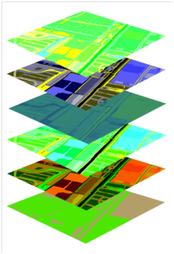

Interception

Resistance/ Friction

Elevation

Infiltration

Vegetation

Soil type

Figure 2-1 Subgrid layers for creating a modelling scheme

### 2.1.2 The calculation grid

The power of the 3Di modelling instrument is the use of bigger calculation cells in combination with the detailed subgrid information (Figure 2-2). Information like the ahn-elevation and land use can be used with high resolution, while the bigger calculation cells make sure the model works fast. The choice of size for the calculation cells will influence the results, therefore it is important to understand the calculation cells for model calculations. The calculation cells are build up by the rules of a quadtree, a scientific method to divide square cells into smaller square cells. An example of the arrangement of calculation cells is shown in Figure 2-2. The most essential characteristic of a quadtree structure is that the dimensions of neighbouring cells are not allowed to differ more than a factor 2.

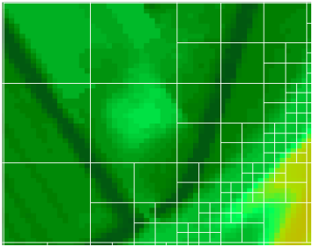

Figure 2-2: Calculation grid with elevation model (subgrid)

By using bigger cells for calculating the model works faster. Rougher measurements are possible when there the current does not change a lot, for example when addressing the surface runoff when there is little variation in elevation. When there is a lot of variation in elevation, the current will be more variable and smaller calculation cells will be needed.

### 2.1.3 Surface runoff

The basis for the calculation of flow is solving the continuity and momentum equations of Saint-Venant. The model bases its calculations on depth averages shallow water equations? (Het model rekent op basis van dieptegemiddelde ondiepwater vergelijkingen). With these equations it is possible to calculate for each time step the amount of water that can flow to neighbouring calculation cells. The difference in water level is what causes the flow between calculation cells.

Each calculation cell contains multiple subgrid pixels (for example from the elevation map), but only has one water level in each cell. The model will divide this water level over the pixels of the elevation map so that is becomes visible which parts are under water and which are not. The relationship between the water level in a calculation cell and the pixels of the elevation map (and the friction map) are pre-stored in charts. Therefore the model is able to search the chart for the water level that belongs to a certain volume of water while calculating and is thereby able to calculate faster.

The velocity and the resulting discharge between cells is calculated in a different way than the water level. The water level exists in one calculation cell while the velocity is defined between two cells: the water flows from one cell to the other. By determining the velocity the calculation cells will be divide as in Figure 2-3. Because the elevation and the friction of the bottom will be taken into account in both calculation cells the discharge will be precisely defined.

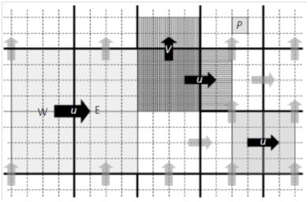

Figure 2-3 Velocity calculation on quadtree level

### 2.1.4 Groundwater Flow

The flow of groundwater is determined by using Darcy’s law. The equation uses the difference in groundwater level between two cells and the permeability index. The calculations cells will not be divided in this case like with surface runoff, because groundwater processes generally have little variation in current.

## 2.2 Vertical calculation method

The 3Di modelling tool is an integral model and can be used for modelling horizontal as well as vertical flows of water. The vertical processes are found within the calculation cell. The average will be calculated from information of the subgrid (or the information will be added in case of interception). Exchange with neighbouring cells occurs through surface runoff or through horizontal groundwater flow. A summary of the available vertical processes can be seen in Figure 2-4.

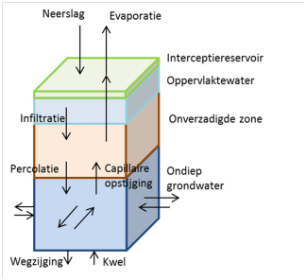

Figure 2-4 Vertical processes within the calculation cell

3Di calculates the vertical and horizontal exchange of water precisely by using the highly detailed subgrids. In this way a precipitation event can not only change over time in an area, but can also vary spatially. The local soil characteristics and land use are directly influencing the runoff of precipitation, because these subgrids are defined in the model.

## 2.3 1D-elements

Some model elements of the water system can be modelled better in 1D. This mainly involves specific characteristics of these elements which are very important for the model (like the discharge equation of a weir). Currently available within 3Di are the following 1D elements; watercourses, constructions (“kunstwerken”, like aqueducts and culverts) and levees/dikes.

### 2.3.1 1D Channel

A 1D network consists of nodes and links which shape the water system. Depending on the type of node or channel there is an exchange taking place between the surface- and groundwater and the links and nodes. This means that the 1D network is more or less detached from the 2D calculation grid.

Velocity points will divide the 1D channels in segments. On these velocity points the momentum equation (Saint-Venant) is solved. This means that the velocity of flows and the discharge will also be calculated at these points. For each section of the 1D channel the continuity equation is solved which as a result will define the water level[1].

The exchange with the 2D calculation grid will take place by using this water level. The 1D network is connected with the 2D calculation grid by water level nodes. In this way the water level in a section of the 1D channel will always have the same water level as the calculation cell which contains the segment. In Figure 2-5 a 1D channel is shown where exchange with the 2D calculation grid can take place. De water level points are drawn as a purple dot in the middle of the calculation cell and are connected to a segment of the channel.

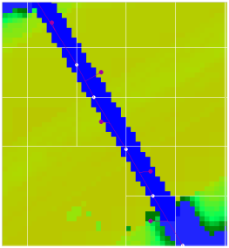

Figure 2-5 1D-channel with velocity( white) and water level points (purple)

There are different types of 1D nodes and channels who differ in their way of exchanging data with the 2D calculation grid which can be different from the example shown above. See paragraph 4.8 for a detailed description of possibilities.

### 2.3.2 Constructions (Kunstwerken)

The water system contains constructions like pumping stations or weirs. These constructions can also be modelled in the 1D network. A Construction will be placed on a velocity point. On this point the flow rate and the discharge will be defined based on the type of construction that is placed on the velocity point. In case of a weir this means that the discharge will be calculated by using an equation for overflow (instead of the Saint-Venant equation). In case of a pump station this means a fixed withdrawal.

### 2.3.3 Levees

Small dikes in the elevation grid will not always be taken into account by the calculation grid. With a levee it is possible to create a wall between two calculation cells in the calculation grid. In this way it is possible to close the barrier between two cells up to a certain height. This means that there it is not possible for water to flow through this side of the cell.

# 3 Modeling with 3Di

This chapter explains all the steps the modeller has to take to create a working model in which the right choices are made. The first step for making a model is collecting data (§3.1). In paragraph 3.2 the outline of a 3Di model is discussed, starting with the most simple model and working up to a more extensive model. In paragraph 3.3 calculating with the 3Di model is explained together with some important settings.

## 3.1 Collecting data

One of the principles of 3Di is that the model schematisation should be controllable.

This is one of the reasons why a design has been chosen that first extracts the basic schematisation (information layers) with all needed data on a high detail level. From this basic schematisations one can then easily create the specific model schematisation, by combining different layers on the desired level of detail.

### 3.1.1 Base schematisation

The basic schematisations are information layers with high detailed and accurate information of the study area. The basic schematisations exist of information on surface level, but also on 1D networks of water flows and barriers. More specific:

Map layers (2D grids) with a resolution of 0.25 m2.

> Elevation

> Land use

> Soil type

1D networks

> Watercourses (including profile and depth of the watercourses and constructions (culverts, weirs, pumping stations, bridges and sluices);

> Raised lines (i.e. barriers/defences);

> Intersections

The basic schematisations will be derived from, preferably the most detailed and complete sources that are available, like basic registrations, register of surface water/ main roads and basic files. These files can be processed and supplemented via the *Data Mining* principle. Hereby extra information will be added by combining data and logic, for example with deriving a continuing watercourse system. All this information will be included in the basic schematisations. The following figure shows this process;

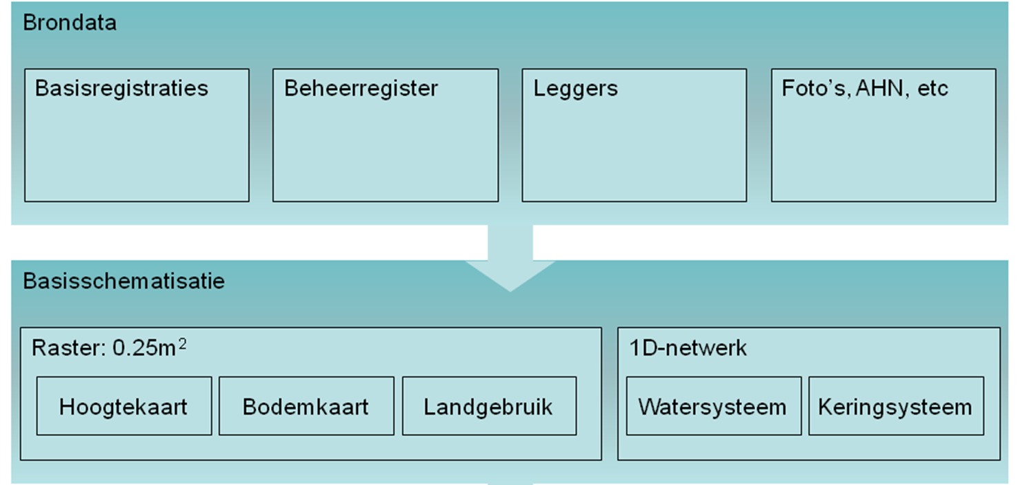

Figure 3-1 The base schematisation is based on up-to-date source data, with added hydrological knowledge.

For extracting the basic schematisations decision trees are made. This makes it clear which working steps are being conducted.

### 3.1.2 Model schematisations

The base schematisations will be used for building a model schematisation. How the basic schematisations need to be processed depends on the research question, de possibilities of the calculation model, the desired performance and the available data. An important step in modelling is determining which processes are relevant for the research question and should be used in the model.

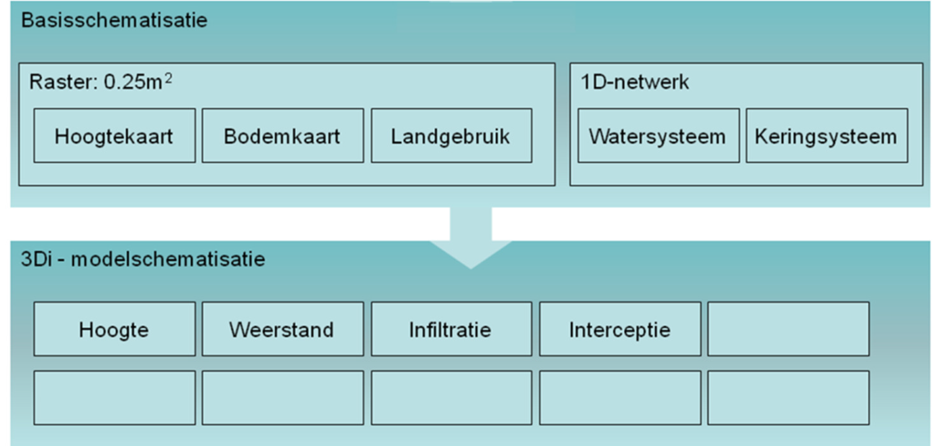

Figure 3-2 The 3Di model schematisation is extracted from the base schematisations

## 3.2 Designing the model

In the following section is shortly described how to design a 3Di model. In paragraph 3.2.1 and 3.2.2 is described what the modeller needs at least to build a 3Di model. In paragraph 3.2.3 to 3.2.5 three the most commonly used models are being discussed. De emphasis is put on the possibilities the modeller has with 3Di, so the modeller can decide for himself which elements are needed for a specific modelling question. All possibilities will be described in chapter 4.

### 3.2.1 The mdu file

Setting up a 3Di model always starts with the mdu file. The mdu is a text file and contains a list with all options and input for the model. In Figure 3-3 an example is given for a mdu.

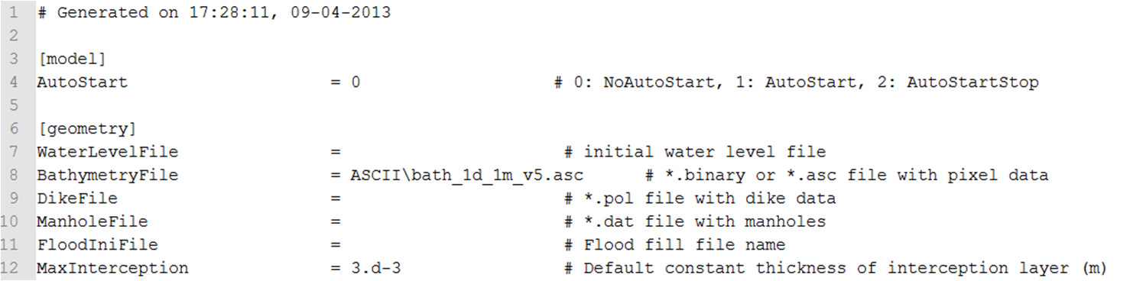

Figure 3-3 Example of a part of the mdu file

In the mdu there is a list of parameters and right after the = symbol it is possible to type something. Here an option can be set (like *AutoStart*), one can refer to an input file (*BathymetryFile*) or a value can be given directly (*MaxInterception*). After the # symbol there is a short description of what the 3Di model expects behind each parameter. There does not always necessarily have to be filled in something, the model will continue to calculate without these parameters or will take a default value instead. The model does at least need an elevation grid.

In chapter 4 all parameters and input possibilities will be discussed in detail. An example of the mdu file is to be found there too. Here one can also get an overview of the map structure we recommend for 3Di models.

I:\3di-Projecten\000-Leeg 3di project\Model\ModelFolderExample

L:\Extern\projecten O (2013)\O0044 - 3Di Waterbeheer jaar 4\O0044.3 Werkgroep

rekenen\Documentatie\MDU

### 3.2.2 Elevation grid and calculation grid, the basis of every model

The elevation grid and a calculation grid are the basic needs for a 3Di model. The elevation grid is a grid file in ASCII (.Asc) or GEOTIFF format. This grid contains a height in meters NAP (*Normaal Amsterdams Peil* or Amsterdam Ordnance Datum) per cell. A link to the elevation grid will come behind the parameter called *‘BathymetryFile’.*

The calculation grid is the quadtree structure as discussed in the previous chapter.3Di is able to derive a calculation grid itself. This can be done by using the options under the heading ‘[grid]’ in the mdu file.

First the smallest calculation cell must be chosen, put this behind *‘GridSpace’*. The minimum size of the smallest calculation cell must at least be twice as big as the size of the cells of the elevation grid. Put the option *‘GuessDams*’ on 0 (zero) and you will get a grid containing only calculations cells of the smallest size. You can use this to test the model or to see if the elevation grid is working correctly.

The calculation grid can be modified to measure more accurate on a local level by using smaller cells, while at the same time using bigger cells elsewhere where less variation occurs. The smallest calculation cells must be used where the highest level of calculation detail is needed. For example on locations where a subgrid (especially height) has a lot of variation. Another example is the flow through a river with **summer dikes (floodplains)** ; here multiple calculations cells are needed over the width of the river. Note that the model gets slower once more calculation cells are used. The current maximum amount of calculation cells is about a 100.000 cells. How to create a fitting calculation grid is described in chapter 4.3.

### 3.2.3 Flood model

A flood model makes use of the so called overland flow. 3Di is ideal for modelling this type of flow and in this way also for making flood models. 3Di uses the elevation model and a surface friction model to model flooding. 3Di can also schematise the source of inundation in different ways.

**Elevation grid and calculation grid**

For creating the flood model you need at least an elevation grid and the corresponding calculation grid. The calculation grid can be modified to calculate more accurate locally by using smaller cells and using bigger cells when there is less variation in height. The smallest calculation cells must be used when the highest detail in calculation is needed. For example when looking at the dikes near the location of a levee breach. Note that the model works slower when more calculation cells are being used. The maximal amount of calculation cells is about a 100.000 cells at this moment. Making a fitting calculation grid is described in chapter 4.3.

**Friction grid**

The friction grid contains the friction of the bottom in Manning or Chezy and needs to be defined in the MDU behind *‘FrictCoefFile*’. The friction grid must have the same dimensions as the elevation grid. The ground friction can also be the same for the whole area, to be filled in behind *‘FrictCoef*’. Also see paragraph 4.2.

3Di uses the spatial variation in bottom friction to model the flow velocity of water over land in detail. The spatial variation in the friction grid can be derived by using the land use grid. As for example the bottom friction of a forest will be higher than the friction of a highway. Note that the size of the calculation grid will also influence this. If there is one highway through a forest in one calculation cell, the calculation cell will get an average surface friction. In reality the water will flow faster over a highway than through the forest. Small calculation cells on the highway will give a better result than one single calculation cell.

**External forces**

In 3Di it is possible to set certain external forces to mention:  
 > 2D External forcing (see 4.11.1)

It is possible to specify the forces at the edge of the model for a variable water level or a discharge. The edge really means the edge in this context, so there cannot exist ‘*NoData’* on the edge. These conditions can be used for modelling a river section, in which a discharge flows in at the upstream side of the model. Downstream a water level can be given as force.

> 1D External forcing (see 4.11.2)

This forcing can be used everywhere in the model and can be used for a variable water level or a discharge. This force uses a small part of the 1D network and can also be connected to a more extensive network. Use this forcing for an overflow or a breach that is not on the edge of a model.

> Manholes (see 4.6)

Manholes are locations where a fixed discharge enters or leaves the model. Manholes can represent a drain when a negative discharge is used, but can also be used when it is known how much water will flow into the model through a breach. A drawback of this is that the manholes use a constant discharge.

> Reservoir in model

The last possibility is to build a reservoir into the model and to fill this with water. A breach will be modelled by emptying this reservoir in a polder or an urban area. This method can be used for a flooding from a drainage canal or for example the IJsselmeer.

Flooding can also be a result of heavy rainfall, see the description of this under flooding model.

**Levees**

Levees are elevations in the height grid. 3Di only includes these levees if they are also visible in the calculation grid. If the calculation cells are too big the calculation model will, so to speak, step over the levee.

To be sure that a levee will be visible for the model the dike will be included as a line in the *‘LeveeFile’*. In this way the calculation cells will be closed at the levee until a certain water level is reached. See paragraph 4.7 for a detailed description.

**Important options**

Flooding is accompanied by high flow rates, therefore it is important to allow for advection in the calculation. To do this the option *‘Advection’* must be set at 1 in the mdu.

With the option *‘OpenLinkCheck’* the flow of water to a neighbouring cell can be prohibited when there is an elevation in the height grid. This function helps to include elevations in the height grid which are smaller than the calculation cells in the calculation. This option can also be used when a calculation cell seems to leak, but will also cost a lot of calculation time. A local refinement of the calculation cells or the use of a levee can therefore be more useful in some cases. Also see paragraph **0.**

Teta 1D/2D?

### 3.2.4 Flooding model polder

An important aspect of the precipitation- discharge relation of the water system is important when making a flooding model on land. The water system will therefore have to be modelled in more detail than in a flooding model

Bij een wateroverlastmodel is de neerslag-afvoer relatie van het watersysteem belangrijk.

Het watersysteem zal daarom in meer detail worden gemodelleerd dan in een

overstromingsmodel. Dit betekent dat grondwater, watergangen en kunstwerken over het

algemeen worden meegenomen in de modelschematisatie. Neerslag is waarschijnlijk de

belangrijkste belasting van het systeem.

**Precipitation**

Precipitation can be added to the model in two ways: interactive and via time series. Adding precipitation in a interactive way can be done via the prototype, by clicking you can recreate rainfall. The thickness and diameter of the shower can be filled in behind *‘Rainfall’* and *‘RainfallCloudDiameter’*.

It is also possible to define precipitation based on time (uniform for the whole area). To do this a text file has to be created in which a precipitation series will be defined, this file has to be filled in behind *‘RainfallFile’*.

NetCDF invoer

Also see paragraph 4.11.3

**Interception**

In 3Di it also possible to model interception. For this an interception grid is added to the model which consists of the interception thickness. Precipitation will first fill the interception raster before it falls on the elevation grid and infiltrates or runs off.

The interception grid has the same resolution as the elevation grid. The interception is added for each calculation cell. Only when the volume of the precipitation on the calculation cell gets bigger than the volume of the interception, the precipitation will reach the elevation grid.

The interception grid can be adjusted to for example model green roofs. A really big interception can also be used to keep the precipitation that falls on a certain area out of (the rest of) the model. For example when rainfall that falls on greenhouses flows to tanks instead of directly to the ditches. Be aware of the calculation cell size in this case.

**Groundwater**

In a flood model groundwater has an important role. By using groundwater calculations infiltration and horizontal groundwater flow can be taken into account. ‘*Numlayers*’ has to be put on 1 in the mdu to integrate a groundwater layer in the 3Di model. It is also necessary to fill in all options and files underneath the *[Ground Water]* heading. This means it is not possible to just add the infiltration layer to take infiltration into account in the model.

For groundwater calculations the maximum infiltration capacity and the soil and crop type are needed in grid format with the same resolution as the used elevation grid (respectively; *InfiltrationRateFile*, *SoilTypeFile* and *CropTypeFile*). The thickness of the groundwater layer will set using the *‘GroundLayerElevation’* and *‘GroundLayerElevationAbsolute’*.

The initial groundwater level can be given for the whole area as a grid or as a constant *(GroundWaterLevelFile or GroundWaterLevellni)*. The horizontal groundwater flow is dependent on the permeability of the soil. This will be given (for now) as a constant for the model area in x and y direction *(permeability_x and permeability_y)*.

The input for the 3Di groundwater layer and a detailed description of these processes is described in paragraph 4.12.

**Water system as 1D network**

The water system of channels and ditches can be schematised as a 1D network in 3Di. The 1D network will take the profile of the channel in detail into account which makes it possible to calculate the flow through the channel accurately. There are three different types of channels to be distinguished for different purposes:

> Embedded

> Connected

> Isolated

This three types of channels differ in exchanging their data with the 2D environment. The embedded channel is fully integrated (embedded) in the 2D calculation grid. This channel also shares the water level of the calculation grid. The embedded channel will maintain its own velocity points to model the real flow through the channel. The embedded channel can be used for most ditches in polders where the water level in the channels is lower than the surface level under normal conditions.

A connected channel is linked to a 2D calculation grid by means of an overflow relation. Hereby you can think of a belt channel/ drainage system (boezem). The water level in the belt channel is mostly higher that the ground level in the polder, the levee of the channel makes sure that the water stays in the drainage system. With the connected channel it is possible to model the belt channel levee. If the level of water in the belt channel rises above the levee, than the discharge that flows over the embankment will be calculated using an overflow equation. The bottom of the connected channel can also exceed the height in the 2D elevation grid.

For embedded as well as connected channels velocity points will be put on the edges of the calculations cells (velocity points are the calculation points of the 1D network). The channels are thus depending on the calculation grid for their velocity points. One segment of the channel must therefore cross two cell walls (and therefore be $\sqrt{{Gridspace}^{2}+ {Gridspace}^{2} }$ long).

The isolated channel is fully disconnected from the 2D calculation grid, the water level is independent of the water level in the calculation grid and there will be no exchange between 1D and 2D. The isolated can be used for modelling external forcing. These channels can also be outside the elevation grid and the calculation grid (spatially). Therefore parts of the water system which are beyond the study area can still be modelled.

While modelling think of the type of 1D channel that fits the watercourses in the study area best. For small ditches in an area without elevation, where the flow velocity is low it is sometimes useful not to use 1D channels. Digging ditches in the elevation map will probably lead to sufficient drainage and will make it possible to use bigger calculation cells.

The size of the calculation cells is also important. If you expect water disturbances, make sure that there are small calculation cells in that area. If there is an unsuspected flooding somewhere then reduce the size of the cells in that area or choose a connected channel. One calculation cell can only have one water level. The volume will then be distributed over the calculation cell whereby as a result only the lowest parts will be under water.Therefore it may look like the watercourses are leaking (Figure 3-4).

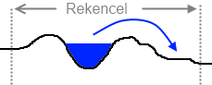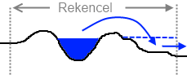

Figure 3-4 Example of an embedded channel that will leak because the calculation cell is too big.

A description of the input for the 1D network is described in paragraph 4.8.

**1D External forcing**

External forces can be connected to the 1D network. You can do this by using a separate node and a link to the network (through an isolated channel). It is possible to set a discharge or external force with the use of time series. An example of the use of an external force is modelling an overflow from the sewer system. If the discharge is known this can be imposed to the model and the effect of the overflow can be visualised. See paragraph 4.11.2 for a detailed description of the possibilities and the files needed.

**Structures**

It is possible to model structures in the 1D network. There are different kinds of structures we can think of. At this moment a weir, a pumping station and a culvert (onderlaat) can be modelled. The structures will be defined separately, but will ‘snap’ to the nearest 1D velocity point.

The measurements of the calculation cells are around the structure are also important when modeling structures. When modeling it is possible that the water will flow around the weir in the 2D elevation grid. And when modeling a pumping station the water is not allowed to flow from the high discharge side back into the polder through the 2D grid. So when creating a pumping station an isolated channel in any case.

Onderlaat

Duikers

The input for structures differs per type of structure and is described in detail in paragraph 4.9.

**Important options**

Evaporation can be turned on or off in the mdu by filling in 1 or 0 behind ‘*Evaporation’*. The evaporation depends on the water content of the soil and the type of crop. The evaporation will be calculated by using the CAPSIM-method (see Sobek manual). Monthly averages are used for potential evaporation. Therefore it is important to fill in the right starting date of the model behind *‘StartDate’.*

At which water depth the water starts to flow to neighbouring cells is determined by the parameter *‘FloodingTreshold’.* The depth of the water will be determined on the resolution of the elevation grid.

Advection barely has any influence if there are low flow velocities. The option ‘*Advection’* can therefore be turned off. This option is only available in case of surface runoff (2D), in the 1D network advection is always included.

With the option *‘OpenLinkCheck’* the flow of water to a neighbouring cell can be prohibited when there is an elevation in the height/ elevation grid. The function tries to include elevations of the height grid which are smaller than the calculation cells. This function can be used if the calculation cells seem to leak, but will cost a lot of calculation time. A local refinement of the calculation grid or the use of a levee can therefore be more useful. Also see paragraph 0.

Teta 1D/2D?

### 3.2.5 Urban flooding model

A model for flooding in an urban area will be similar to an polder flooding model in many respects. For example the model can contain a 1D network, interception (green roofs) and ground water and will probably also have to deal with precipitation. Most of the settings will therefore be the same as described above. It depends on the kind of research question which parts are needed.

**Sewer system [to be completed]**

The sewer system can be modelled by using manholes or a negative discharge. This negative discharge will correspond with the HWA (hemelwaterafvoer or rainwater discharge) to the sewer through storm drains. Note that a manhole withdraws water from the volume on the calculation cell. The discharge through the manhole is constant and cannot be adjusted. It will thus not take in account the exact location of the storm drain.

**Important options**

In urban areas the option *‘OpenLinkCheck’* is highly recommended. In the elevation grid of the urban area the structure of streets and building

The streets and the gardens behind housing blocks are low compared to the height of the building block The *‘OpenLinkCheck’* makes sure that the water on the streets does not flow to the backyards (think of the housing block as a summer dike and the backyard as the river foreland). By turning this option on les calculation cells are needed. Also see paragraph 0.

Another important setting in the urban area is the *‘FloodingThreshold’.*

## 3.3 Calculating

Before starting the calculation there are a few important settings. These are discussed below.

**Initialisation**

Initialising the 3Di model consists of two steps. The first step is setting the initial conditions. In the mdu the following initial conditions can be set:

* *WaterLevelFile* Initial water level as grid (spatial variation)
* FloodIniFile File with the water levels on xy-coordinates. From the location the set waterlevel will be ‘floodfilled’. 3Di will set a water level until it meets a height grid cell which is higher than the given water level.

Note: Will not take the *LeveeFile* into account

* *WaterLevellni* Initial water level constant for the whole model
* *GroundWaterLevelFile* Initial groundwater level as grid (spatial variation)
* *GroundWaterLevellni* Initial groundwater level constant for the whole model

These conditions will not be applied right after starting the model. Only when the calculating starts these water levels will be divided over the calculation cells of the model. After this second step in the initialisation is is possible to save the state of the model in a *Gridadministration* and a *Tabledata* file. The *Gridadministration* file contains the information of the calculation grid and the *Tabledata* file will contain the information from the subgrids per calculation cell. By saving these files and by putting them in the mdu behind *GridAdminFile* resp. *TableDataFile* the model will start faster next time.

**Time steps**

The calculation time step of the model will be added behind Dt. The size of the time step depends on the expected flow velocities in the model and the size of the calculation cells. If water flows faster it will travel a bigger distance per time step. If this distance is bigger than the calculation cell the water flows through it might be wise to reduce the size of the time step. For a flooding model a time step of a minute is suitable and for an urban or polder flooding model time steps of a few minutes are more appropriate. For groundwater one can use bigger time steps, because of the low velocity of the flow.

The starting date will be used for the evaporation, because it works with monthly averages. The starting time shifts the first value which will be used from possible conditions (De

starttijd verschuift de eerste waarde die wordt gebruikt uit eventuele randvoorwaarden).

The model will stop calculating if the maximum amount of time steps behind ‘*NTimesteps’* is reached.

**Output**

The results will be saved in *´NetCDF´* format. De resultaten worden opgeslagen in *‘NetCDF’* formaat. The map.nc contains results for all calculation cells. The his.nc contains all results in the *‘ObsFile’* and *‘CrsFile’* (see below). With the options *‘MapInterval’* and *‘HisInterval’* the time step for these results can be influenced

In the prototype it is possible to not visualise every calculated time step on the screen. Therefore the option *´LogOut´* can be used. If one would for example fill in 10 only every tenth time step will be visualised. In this way the model will calculate faster.

# 4 Model components

## 4.1 Table overview MDU

This table will give a summary of the mdu file and its contents.

4 Model components

**4.1 Table overview MDU**

|  |  |  |  |
| --- | --- | --- | --- |
| Option | Unit | Description | See |
| [model] |  |  |  |
| AutoStart |  | 0) Do not start automatically  1) Start automatically  2) Start automatically and stop at shutting off |  |
| [geometry] |  |  |  |
| WaterLevelFile | m NAP | Grid file containing initial water level for the whole modelling area. Can not contain no_data,  not even on the edge of the model area. | 4.2 |
| BathymetryFile | m NAP | Elevation grid of the model. The resolution of the elevation grid determines the resolution of the model. | 4.2 |
| DikeFile |  | Files with one or more polylines or polygons with which spatial specific refinement can be added to the calculation grid. | 4.3.2 |
| ManholeFile | m NAP | File with manholes. List with locations and capacity | 4.6 |
| FloodIniFile | m NAP | Floodfill file existing of x, y, z values. With x and y being the coordinates of the flood fill point and z being the water level in mNAP wit which the point will be floodfilled. |  |
| MaxInterception | m | Maximum thickness of the interception layer [m], with no spatial variation. Maximum water storage on the surface; water that will never runoff or infiltrate, but is only able to evaporate. If there is no interception grid given this value will be constant for the whole model. |  |
| MaxInterceptionFile | m | Spatially varying maximum interception layer on grid resolution. In this file type of land use in relation to storage on the surface can be distinguished. Can not contain no_data. | 4.2 |
| NetworkFile |  | Text file with 1D watercourses network. In this file nodes, cross sections, types of channels and links between nodes can be defined. | 4.8 |
| LeveeFile |  | Text file with levees. In this file the nodes, height of the levee and the links between the node scan be defined. | 4.7 |
| StructureFile |  | Text files containing structures. | 4.9 |
| [grid] |  |  |  |
| GridAdminFile |  | A .grd file with a previously generated calculation grid that can loaded automatically. |  |
| TableDataFile |  | A .tbl file with the previously generated tables can be loaded automatically. | 4.3 |
| GridSpace | m | The minimum size of the calculation cells in meters. | 4.3 |
| kmax |  | Maximum refinement level. For refining the next equation is used: | 4.3.1 |
|  |  | Biggest calculation cell = Gridspace x 2Kmax-1. |  |
| BathDelta | m | The maximum accepted difference in height between pixels in meter within a calculation cell when using automatic refinement of the calculation grid. | 4.3.1 |
| BathMax | m | If the bottom height in meters within a calculation cell will not fall below this value, the calculation cell will not be automatically refined. | 4.3.1 |
| GuessDams |  | 0= calculation grid consists solely of the biggest calculation cells.  1= calculation grid will automatically be refined | 4.3.1 |
| [initialization] |  |  |  |
| WaterLevelIni | m NAP | Initial water level [m NAP] uniform for the whole area. If you do not want to define an initial water level fill in -99. |  |
| FloodWaterLevel | m NAP / m | Floodfill water level [m NAP], this is the water level with which you can floodfill an area in the prototype. |  |
| FloodLevelAbsolute |  | Choice if the FloodWaterLevel is absolute (1) or relative (0).When using absolute there will be a flat water table on the given height. When using relative there will be a water table with a slope and a fixed depth. |  |
| BathymetryIncrement | m NAP / m | Value for the interactive adjustment of the elevation grid. |  |
| BathIncAbsolute |  | Choice for an absolute height adjustment (1) or a relative (0) adjustment in the prototype. When choosing absolute you will raise or lower the bottom height [m NAP] which is given at BathymetryIncrement. When choosing relative you will raise or lower the bottom height with a given value. |  |
| InfiltrationRateNew | mm/ day | Value for interactive adjusting of the infiltration capacity [mm/day]. |  |
| Rainfall | m | Fixed amount of precipitation which can be interactively added to the area. Will be presented as an instantaneous disk of water [m]. |  |
| RainfallCloudDiameter | m | Diameter of the added shower [m]. |  |
| [numerics] |  |  |  |
| Teta |  | Choice to include part of the outcome of the previous time step in calculating water levels and flow velocity. 0.5< Teta < 1  0.5 = semi-implicit, 1=fully implicit (everything on a new time step) |  |
| FloodingThreshold | m | Threshold that determines from which water depth water starts to flow between the cells. When the water level in a calculation cell is higher than this value it is possible to flow to a neighbouring, lower cell, the cell wall will open. When the water level is lower than this threshold (even if it is possible for the water to flow to a lower neighbouring cell) the water will not flow through the cell wall. Calculation times at cells that are on the edge of getting wet will rise quickly. By adding a threshold the calculation time will be limited. Value: 0 – $∞$. |  |
| OpenLinkCheck |  | Choice for the method to open flow-links. Option 0 examines if a neighbouring calculation cell has a lower bottom height. If yes, the water will flow to another cell. Option 1 examines if there is a ‘wet path’ available from the middle of the cell to the wall of the cell. Option 1 will take in account elevated element in the calculation cell. Option 0 does not acknowledge these elements and only looks at the surface heights in the calculation cells.  Note the flow at the levees: locally refining the calculation cells around levees or schematising levees makes sure that the flow between for example the main channel levee and the flood plain is blocked. | 0 |
| Advection |  | Choice to turn the advection on (1) or off (0). At high velocity flows through a relatively small opening (breach or manhole) advection need to be turned on. For calculating precipitation effects advection can be turned off. Without advection de calculating will go faster.. |  |
| [Physics] |  |  |  |
| FrictType |  | Choice for type of friction; option 0 is Mannin and option 1 is Chezy. |  |
| FrictCoefFile | Manning/Chezy | Grid file with spatially varying friction values with the same resolution as the elevation grid expressed in Manning or Chezy (Depending on FrictType) | 4.2 |
| FrictCoef | Manning/Chezy | Spatially uniform friction value expressed in Manning or Chezy (Depending on FrictType) |  |
| [ground water] |  |  |  |
| InfiltrationRateFile | mm/day | Grid file containing the spatial varying infiltration capacity [mm/day] with the same resolution as the elevation grid. The file may not contain no_data. | 4.2 |
| NumLayers |  | Amount of defined base layers. At this moment only 1 layer can be modelled. If groundwater should not be taken into account fill in 0, otherwise use 1 as a value. |  |
| GroundLayerElevation | m / m NAP | Height of the lower boundary of the model. This height must always be lower than the surface height. |  |
| GroundLayerElevationAbsolute |  | Choice to give the height defined above in relation to the NAP (option 1) or to set a relative depth underneath the lowest point of the surface in the calculation cell (option 0). When using option 1 a constant height will be set. Using option 2 will set a spatially varying height. |  |
| GroundWaterLevelIni | m NAP | Uniform initial water level. |  |
| GroundWaterLevelFile | m NAP | Grid file with spatially varying water levels with the same resolution as the elevation grid. Can not contain no_data. | 4.2 |
| MoistureContent |  | Choice for the initial ground moisture content. Option 0 will set the round moisture content on “wilting point”. This means there will be just enough moisture in the ground to feed the crops (field |  |
|  |  | capacity). Using option 1 will set the moisture content on equilibrium. |  |
| permeability_x | m/s | Uniform permeability [m/s] in horizontal direction. Depends on the soil type. |  |
| permeability_y | m/s | Uniform permeability [m/s] in vertical direction. Depends on the soil type. |  |
| SoilTypeFile |  | Grid file of the soil type with the same resolution as the elevation grid. There are 21 soil types. Each pixel will get a code representing the soil type. | 4.2 |
| CropTypeFile |  | Grid file of the crop type with the same resolution as the elevation grid. There are 16 crop types. Each pixel will get a code representing the type of crop. | 4.2 |
| [time] |  |  |  |
| Dt | s | Calculation time step [s] for calculating surface water flow. Indication for the time step is the calculation cell size; with a 2D-grid of 50 x50 cm a Dt of 1 minute is a fair assumption. This is the same for 1D flows in which the distance between calculation points is leading. |  |
| StartTime |  | Initial starting time [hh:mm:ss]. Note: the starting time shifts to a given time series (precipitation or external forcing). |  |
| StartDate |  | Reference date [yyyy-mm-dd]. Important for evaporation. |  |
| NTimesteps |  | Duration of the simulation expressed in amount of time steps to be taken [-]. When the calculation is not interrupted it will stop when the given amount of time steps is reached. |  |
| [external forcing] |  |  |  |
| ExtForceFile |  | File containing settings for your external forces (.ext). This file contains a reference to other files (time series, locations, values). | 4.11 |
| ConstantRainAmount | mm/day | Constant amount of precipitation that falls on the whole area [mm/day]. This amount of water will added to the calculation cell for each time step. |  |
| RainfallFile | mm | File containing the time series that holds the amount precipitation. Each time step the precipitation will be added spatially fixed to the whole area. | 4.11.3 |
| Evaporation |  | The choice to turn the evaporation of the interception layer on (1) or off (0) . |  |
| [output] |  |  |  |
| LogOut |  | Amount of time steps between plots of results in the interface. When you want to visualise the result of each time step fill in 1. Visualising results costs a lot of time therefore you can choose to visualise only one in x time steps. |  |
| SaveHardCopy |  | Choice whether to save prinstcreens (1) or not (0). The amount of prinstscreens is determined by the LogOut time step. Saving prinstcreens costs a lot of calculation time and is not recommended. |  |
| showGrid |  | Choice whether to show the quadtree grid in the interface (1 = show and 0 = do not show). |  |
| showLinks |  | Choice whether to show flowlinks in the interface (1=show and 0 = do not show). |  |
| MapInterval | s | Output interval for saving results on the calculation grid. For each calculation cell the results for each interval will be saved. |  |
| HisInterval | s | Output interval for saving results on observation points or cross sections. For each point a time series is saved. |  |
| ObsFile |  | File (x, y, n ) with the location (x,y) and name of the observation points. On these spots time series will be saved for every output parameter (water levels and depths). |  |
| CrsFile |  | File (.pol) containing the location of the polygons which save the time series for each output parameter (discharge and flow velocity. |  |
| [colors] |  |  |  |
| LandColorMapFile |  | File containing the information about the colouring of the ground height. For each interval there will be a set colour code. |  |
| LandColorType |  | Choice for the colouring of the ground height Option 2 will use the file that has been given at LandColorMapFile. Option 1 will automatically generate the colours. Option 0 gives the user the opportunity to set a lower and upper boundary (cmax and cmin) between which the default colours will be distributed (linear). |  |
| cmax |  | Upper bound for colouring the bottom height [m NAP]. All areas higher than this value will get the same colour (red). |  |
| cmin |  | Lower bound for colouring the bottom height [m NAP]. All areas lower than this value will get the same colour (dark green). |  |
| WaterColorMapFile |  | File containing the information about the colour of the water. For each interval a colour code will be given. |  |
| WaterColorType |  | Choice to automatically generate the colour scale for water depth (1) or to set an upper boundary representing the water depth (1). Between the upper boundary (maximum water depth) and 0 the colour will be set by interpolating. |  |
| hmax | m | Upper bound [m] for the colouring of the water depth. Depths above this value will get the same colour (dark blue) |  |
| hmin | m | Lower bound [m] for colouring the water depth. Starting from this water depth the water will be visualised. |  |
| InterceptionColorMapFile |  | File containing the information about the colouring of the interception. For each interval a colour code will be set. |  |
| simax | m | Upper bound [m] for colouring interception. |  |
| simin | m | Lower bound [m] for colouring interception. |  |
| gwmax | m | Upper bound [m] for colouring the ground water level. |  |
| gwmin | m | Lower bound [m] for colouring the ground water level. |  |
| ShowUZslice |  | Choice to either visualise the unsaturated/vadose zone (1) in side view or to not visualise the unsaturated zone (0) in side view. |  |
| sliceUZcolor |  | Choice to colour the unsaturated zone in one colour in the side view (0) or to let the colouring depend on the soil moisture (1). |  |
| showInterception |  | Choice to visualise (1) the interceptive water or not (0). |  |

## 4.2 Grids

## 4.3 Calculation grid

The first thing to do when creating a calculation grid is choosing the size of the smallest calculation cell (*GridSpace)*. De smallest calculation cells must first be applied where the highest calculation detail is needed. For example on locations where the subgrid (especially height) is strongly varying. Another example is the flow through a river with summer dikes; here more calculation are needed over the width of the river.

The minimum size of the calculation cell is at least twice as big as the resolution size of the height/elevation grid.

The next step is to determine the maximum size of the calculation cells by setting the maximum refinement level *kmax.* With this factor and the smallest calculation cell size the maximum cell size will be calculated: Biggest calculation cell = Gridspace x 2Kmax-1.

Creating the calculation grid can be based on a pre-selected cell size or different characteristics or subdivisions in the landscape. These are for example flood defences, specific areas or areas with a lot of difference in height. A combination of the two methods is also possible. This makes it possible to create an optimal calculation grid. Optimal means a trade-off between calculation speed and level of detail.

### 4.3.1 Automatically defined grid

A constant calculation grid of the biggest cells will be made by 3Di when 0 is filled in at *‘Guessdams’*.

By filling in 1 at ‘*GuessDams*’ 3Di makes a constant calculation based on the differences in height in the elevation grid. Areas with a lot of variation in height will get the smallest calculation cells. Areas without elevation will get bigger cells. The calculation grid can be influenced with two parameters.

The computational core will look at the maximum difference in ground level between the pixels of the height grid inside the biggest calculation cell. If this difference is bigger than ‘*BathDelta’* the calculation cell will be divided in four cells. This process will be repeated until the maximum height difference within a cell is smaller than ‘*BathDelta’*.

By using the parameter ‘*BathMax’* a threshold for the maximum ground level will be chosen. Above this level calculation cells will no longer be refined.

### 4.3.2 Dike-file

A *dike-file* appoints areas or line elements where the calculation grid should be refined. The following figure shows a quadtree grid from Hoogheemraadschap Delfland with very good ratio between velocity of the calculation (amount of cells) and the appropriate detail level for flooding problems. The grid is based on a constant cell size with local refinement based on the location of flood defences. The cell size is 400m and the size of the cells that are locally refined is 25m. The inundation pattern around the flood defences (strong variation in surface height) can be calculated in detail because of the refinement. When creating flooding models this will make sure that there is a detailed calculation grid where this is important and needed.

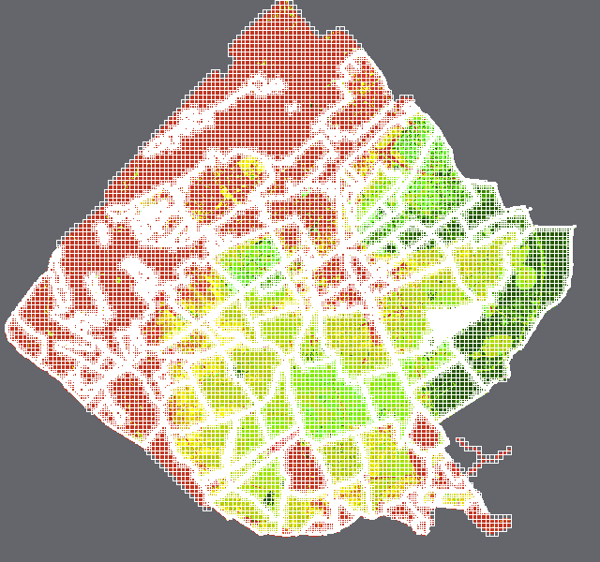

*Figure 4-1 Manual generation for optimal quadtree calculation grid.*

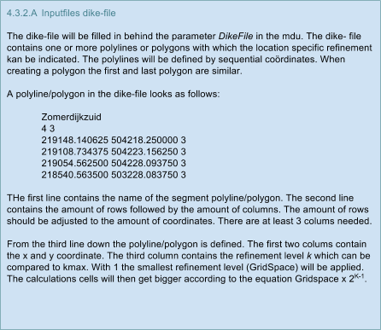

## 4.4 Model options

Some options in the model or characteristics of the calculation cells can be configured.

### 4.4.1 Teta

### 4.4.2 OpenLinkCheck

The flow calculations and with that the movement of water between calculation cells runs over the edges of the calculation cells. The purpose of *‘OpenLinkCheck’* is closing the edges of the calculation cells when there is an elevated line element (smaller than the width of the calculation cell) within the calculation cell. In this way the flow of water to a neighbouring cell is prohibited until it reaches the defence height of the elevated line element.

The function will be explained with the situation below (Figure 4-2). In the figure two elevated line elements (the red levees) can be seen which run along the watercourse (dark blue). Behind the dikes are the floodplains (light blue). The discharge flows from west to east (black arrow) and the calculation cells are striped black. The function *OpenLinkCheck* is described for situations where the function is off and the situations in which the function is turned on for the watercourses that run parallel to the calculation grid (N-Z/ O-W) and the ones that are turned (the watercourses that are drawn at an angle. The last type is usually seen on the land.

**Function turned off when watercourses are parallel to the calculation grid (N-Z/O-W)**

When the water levels in the watercourse (river) are low the water is not allowed to flow to the floodplains because of the levees. However an error in the calculation of the flow will arise when the calculations cells are bigger than the width of the levee. Because the whole calculation cell will have one water level this means that the water level in the floodplains will be the same as the water level in the channel. The water will not be stopped by the levee which will eventually lead to flows in the direction of the floodplains.

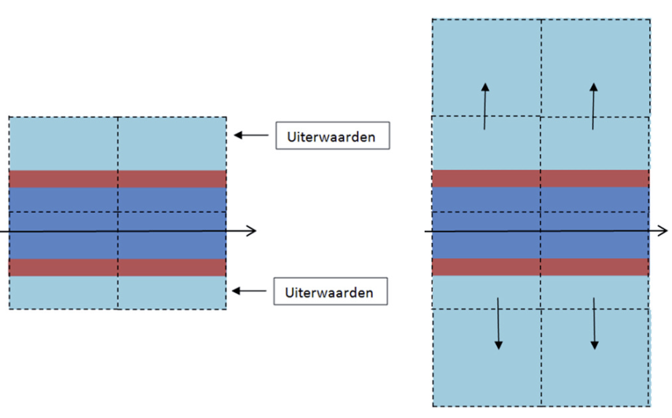

Figure 4-2: Situation in which *‘OpenLinkCheck*’is off. Because of the size of the calculation cells the cell which contains the levee will have only one water level which leads to a flow of water to the floodplains (the underlying calculations cells).

**Function turned off with watercourses at an angle in respect to the calculation grid**

The situation of the flows to the floodplains will also occur in situations in which watercourses do not run parallel to the calculation grid, but are at an angle (Figure 4-3). Here too the whole area overflows in the 3Di calculation in spite of the levee next to the watercourse.

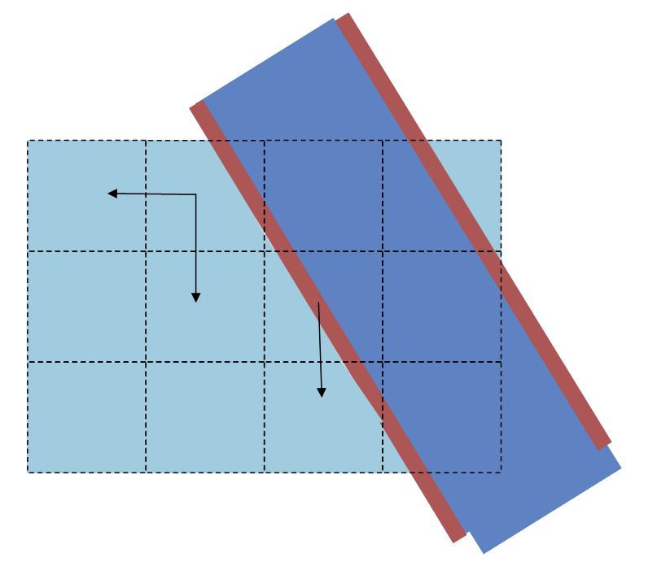

Figure 4-3: Situation in which *‘OpenLinkCheck’* is off and the flow of water to the floodplains takes place at watercourses which are at an angle to the calculation grid.

**Function turned on when watercourses are parallel to the calculation grid**

*‘Wet path’*: The definition of a wet path is a path (in the subgrid) from the centre line of a calculation cell in the direction of the neighbouring cells (4 directions). This path will become ‘wet’ when the water level in the calculation cell is higher than the surface level in all pixels.

When the function *‘OpenLinkCheck’* an imaginary line will be constructed in the middle of the calculation cell (Figure 4-4 and Figure 4-5). The imaginary line is being represented by the green striped lines in the figures. 3Di looks in every possible way if it can find a wet path in the direction of the neighbouring cell. In the situation that can be seen in figure 3a a complete wet path (green arrow) is found in the direction of the cell above. This is because there is no levee (elevated line file) found between the centre line and the edge of the calculation cell. The flowlink between the two calculation cells (yellow) will open and the water can flow to the neighbouring cell. If the water levels in the river get higher than the surface height of the floodplains, but not per se higher than the levee, the floodplains will flood. In reality this will not happen.

When there is a levee between the centre of the calculation cell and the neighbouring calculation cell a complete wet path will not be found. The flowlink between the two calculations cell will remain closed (red line) and will only open when the water level in the calculation cell exceeds the height of the levee. The floodplains remain dry during ‘normal’ water levels (figure 3b).

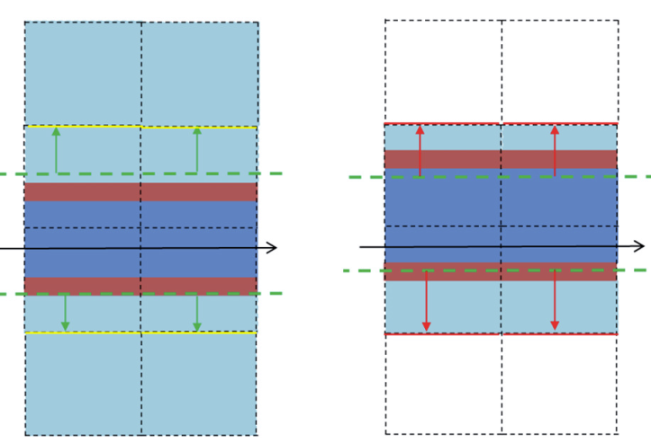

Figure 4-4: (Left) Overhead view of a river with a levee and floodplain within. With the presence of a wet path from the centre of the calculation cell (green line) to the neighbour cell (green arrow) the water is able to flow (flowlink, yellow, open).

Figure 4-5: (Right) In this case there is no complete wet path found (red arrow), because there is a levee between the centre of the calculation cell and the neighbour cell. The flowlink is now closed (red) en will only open when the water level exceeds the height of the levee.

**Function turned on when watercourses are at angle to the calculation grid**

The *‘OpenLinkCheck’* function does not work for watercourses that are not parallel to the calculation grid. Sometimes a wet path will be found despite of the presence of a levee in the calculation grid. In Figure 4-6 wet paths are found in some calculation cells (green arrows) which results in the opening (yellow) of the flowlink between two calculation cells and the flowing of water to neighbouring cells (yellow arrows). Eventually the floodplains will flood in this situation despite the presence of a levee and the function *‘OpenLinkCheck’* being turned on. An option to prevent this problem is creating smaller calculation cells (Figure 4-7). Hereby the levee is being ,as it were, held captive between two calculation cells.

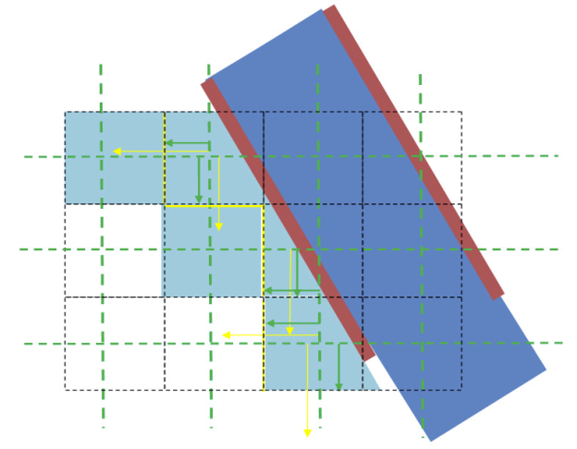

Figure 4-6: *‘OpenLinkCheck’* turned on at the beginning of the watercourses which are at an angle to the calculation cells.

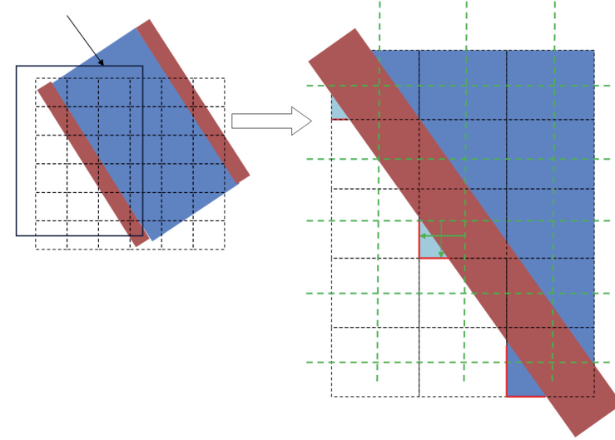

Figure 4-7: Effect of smaller calculation cells with ‘OpenLinkCheck’ turned on.

### 4.4.3 Flooding Threshold

### 4.4.4 Advection

### 4.4.5 Output

- observationFile

- CrsFile

## 4.5 Initialisation

## 4.6 Manholes

A manhole is a location on a random spot in the area where a constant discharge can be imposed on the model. This discharge can be positive (inflow) as well as negative (extraction).

A manhole acts as an addition to the water balance of the calculation cell in which it is located. The discharge of the manhole will be added for every time step. The discharge of a manhole is constant and cannot be regulated.

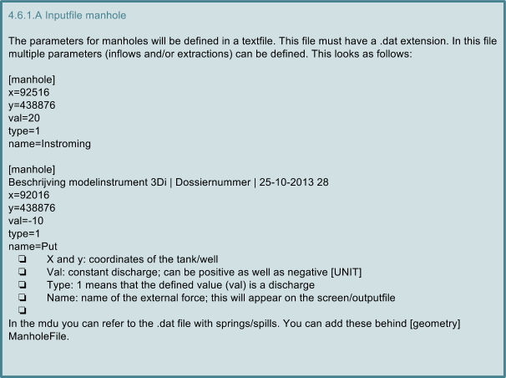

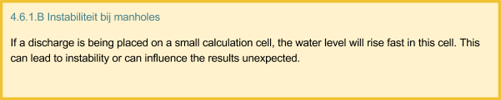

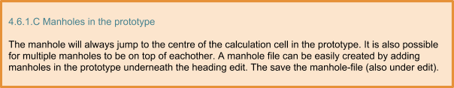

## 4.7 Levee – LeveeFile

The flow rate and the discharge between two calculation cells will be set on the edge of the calculation cells. By using big calculation cells in the 2D grid there is a possibility that a levee will be in the middle of the calculation cell and will not be seen by the 3Di model. There are two possible solutions for this problem: a refinement of the calculation grid or modelling a levee. The levee makes sure that no water can flow over the edge of a calculation cell. The calculation cell will be closed on one side. The levee will have a certain height. If the water level gets higher than the height of the levee than the cell wall will open again.

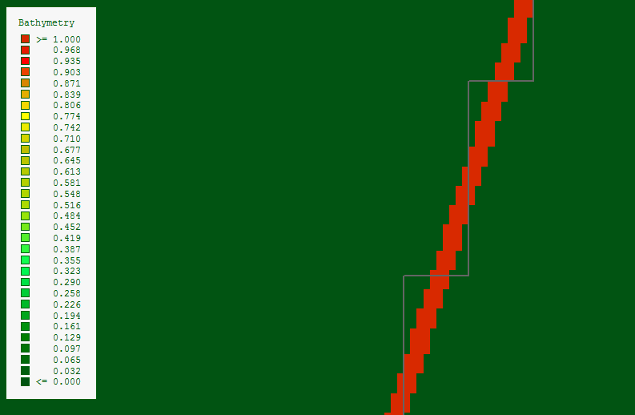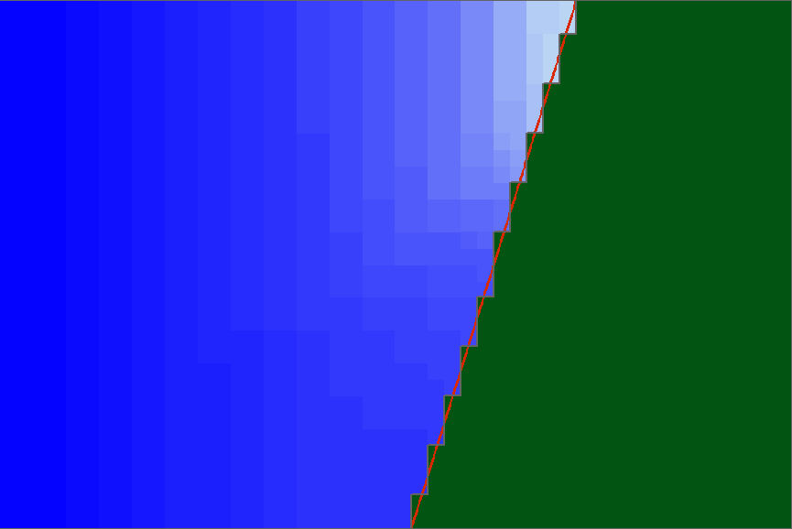Figure 4-8 Levee on the calculation grid (grey line over red levee, left) and flow to the levee.

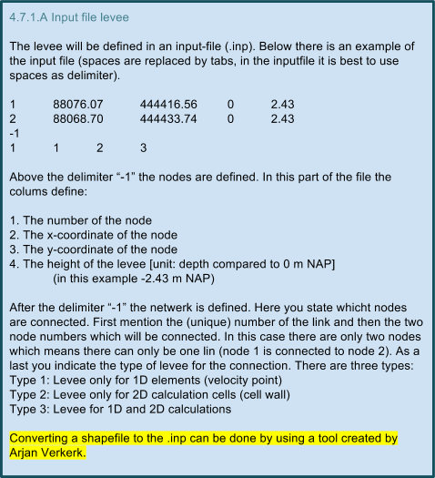

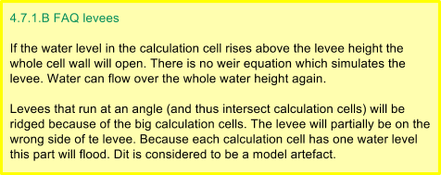

## 4.8 1D-Network – NetworkFile

Three different types of 1D channels can be distinguished:

> Embedded

> Connected  
> Isolated

It is possible to define independent cross sections for these three types of channels to represent the actual watercourses as good as possible. The channels differ from each other in the way they connect to the 2D component. An embedded channel for example is almost integrated in 2D and will have a lot of interaction with 2D. A connected channel has less interaction with 2D, because it is more disconnected from 2D than embedded. Isolated channels do not have any interaction with 2D.

A connection with the embedded channel is made by sharing the water level point of the channel and the calculation cell with 2D (Figure 4-9). This shared water level point ensures that the channel is in fact embedded in the 2D elevation grid/subgrid. The embedded channel does however keep its own velocity point to model the flow through the channel.

The connected channel is linked to the 2D elevation grid by using spillways. So it is an independent channel with its own water level and velocity points. Channels with a higher ground level than the 2D elevation grid in the low lying polder are perfectly suited to be modelled with a connected channel. In this way a possible high water level within the levees of a channel cannot lead to an unwanted water level in the 2D calculation cell.

The isolated channel is totally disconnected from the 2D subgrid. The channel has its own water level points and velocity points. This means there will be no exchange between the channel and the 2D subgrid.

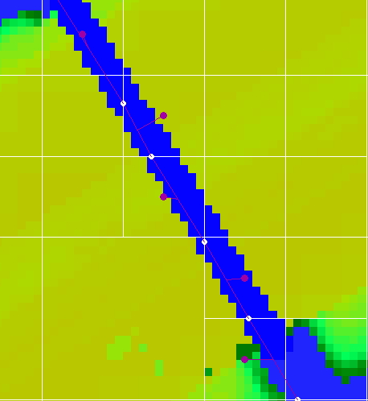

Figure 4-9 Embedded channel, velocity points (white) and water level points (purple)

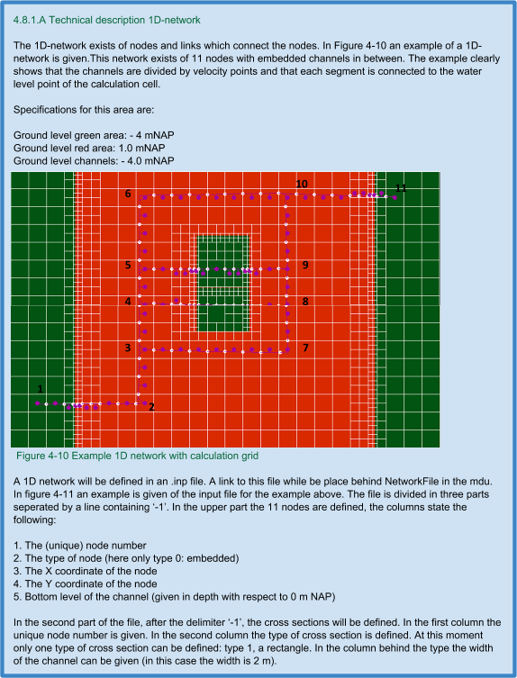

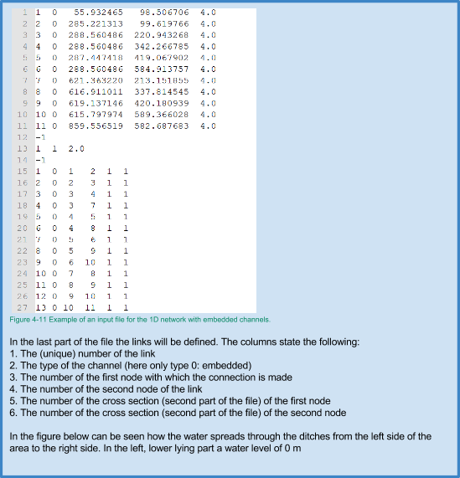

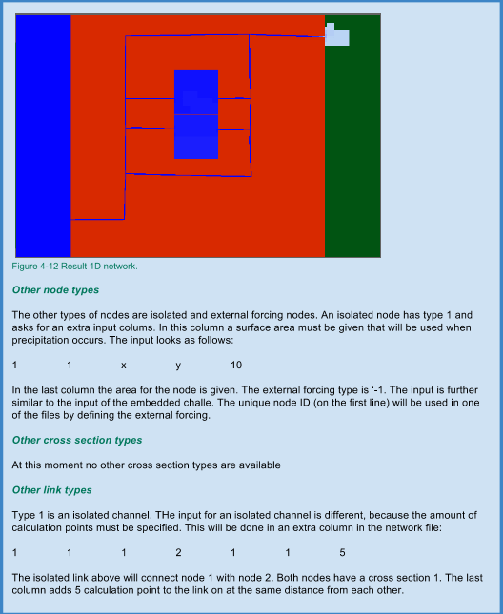

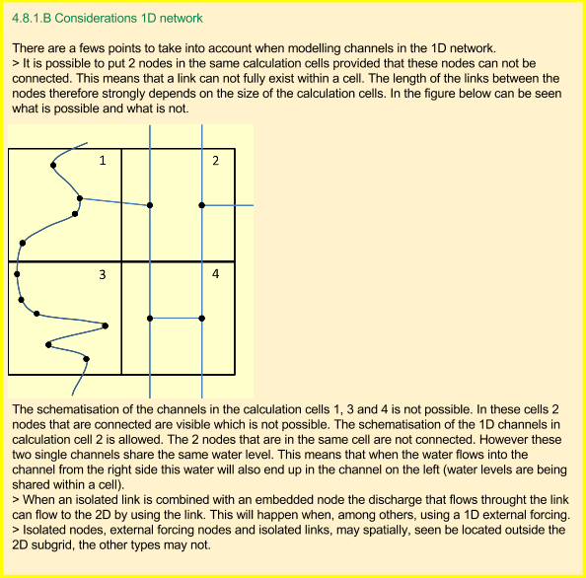

## 4.9 1D Constructions -Structures

### 4.9.1 Weir

1 type of weir, weir equation in accordance with Sobek

**Free weir flow:**



**Drowned weir flow:**



Q = Discharge across weir [m3/s]

c = Discharge coefficient [-]

B = Crest width [m]

g = Gravity acceleration [m/s2]

h1 = Upstream water level [m]

h2 = Downstream water level [m]

z = Crest level [m]

The effect of the weir is calculated on a velocity point, which means that the structure (when linked to an embedded channel) is always placed on the edge of the 2D calculation cell. This is not the case for weirs on isolated and connected channels; here the effect is calculated at the velocity point where the weir is defined.

### 4.9.2 Pumping station

Calculation/connection to the network is the same as the weir.

## 4.10 Sewage system

- not finished yet

## 4.11 External Forcing

External forces can be forced to the model locally. A division can be made between the external forcing on 2D calculation cells, on 1D calculation points and in the form of precipitation.

### 4.11.1 2D-external forcing

Three types of external forcing can forced tot a 2D calculation grid: water level, discharge and q-h relation. The external forces will be forced onto an extra calculation cell which will be made on the edge of the model. The external forces will be set when solving the mass and the momentum equations. This means that an external force is actually a disturbance in the (stable) system. Therefore it can be required to set the external force outside of the model by for example modelling a small channel.

The first type of external forcing is a water level which can be set at the edge of a 2D calculation grid. Because the water level is forced, water can emerge or disappear and a discharge can emerge on the edge of the model. In a chart the course of the water level can be given over time.

The second type of external forcing is a discharge. Hereby for every timestep a discharge is given at an indicated area at the edge of the 2D grid. In a chart the course of the discharge can be given over time.

The third type of external forcing is a q-h relation. Based on the calculated water level a discharge is force. [not finished]

The 2D external forcing must be set along a line at the edge of the 3Di model. The external force will be forced on or divided over all the calculation cells which cross this line. In a separate file a time series is given containing the water level or the discharge. This can vary through time. What these files are supposed to look like is described in box 4.11.1.A.

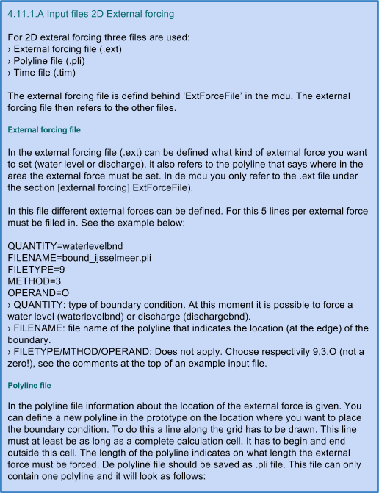

.

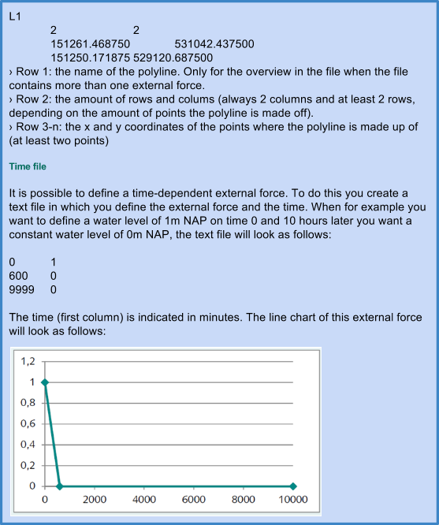

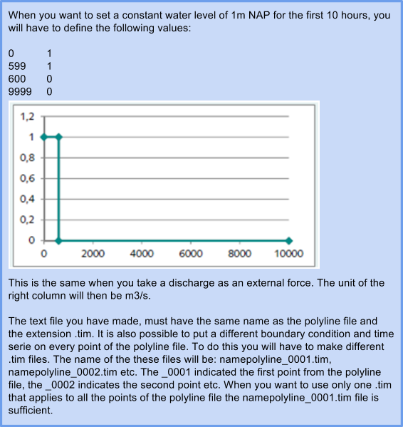

### 4.11.2 1D-external forcing

The 1D boundary conditions are comparable to the 2D boundary conditions. There are three types of external forcing: water level, discharge and q-h relation (not possible yet). 1D conditions connect to the 1D Network and can be forced anywhere in the model.

A 1D external force uses a node and a link (channel segment) which will have to be added to the 1D network (see paragraph 4.8). The node is the place where the external force is linked to the model. This node has no direct interaction with the rest of the 1D network (and thus can be outside the extent of the model). A channel segment with the type ‘isolated channel’ connects the external force to the 1D network. The channel segment can best contain at least three calculation points so the interaction between the external force and the network runs smoothly (versus unstable).

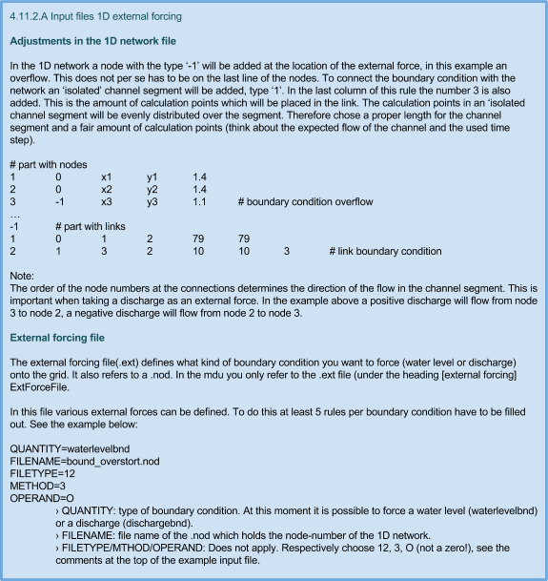

**Node file**

The external forcing file refers to a .nod file for every structure. The .nod file contains the number of a node in the 1D network. This number makes sure that the right external force is linked to the right node in the network file. In the .nod file only a node number is placed on the first line. In the example above this will be the number ‘3’.

**Time series file**

The time series file looks the same as the series for the 2D external force. Two columns with on the left side the time in minutes and on the right side the value defining the water level (m NAP) or discharge (m3/s). In the example above: ‘bound_overstort_0001.tim’. This .time file must have the same name as the .nod file with the addition ‘0001’. It is not possible to link multiple time series to one .nod file.

4.11.2.B Notes with 1D external forcing

Make sure there is an even amount of external forces in the .ext file as external forcing nodes in the network file

The order of the node numbers at the links determines the direction of the discharge in the channel segment.

### 4.11.3 Precipitation

Adding precipitation to the model can be done in three ways:

**>** By using the prototype  
**>** Time series with uniform precipitation for the whole model  
**>** Time series with spatially fluctuating precipitation through time

In the prototype precipitation can be added interactive. By manually clicking you can add a shower. This water flow is not uniform, but smoothed on the edges.

It is also possible to define time depended precipitation (uniform for the whole area). To do this you can make a text file in which you define precipitation series. This file can be defined behind ‘RainfallFile’ in the mdu.

Spatial variation in precipitation can be added with the help of NetCDF [to be completed].

4.11.3.A Input files uniform precipitation series

The input file for precipitation exists as a time series that 3Di can read as a function block. There will be no interpolation between the time steps, but a given value is divided over the time step. This is the same as with the .BUI file used in Sobek.

The input consists of a column on the left side with time in minutes en precipitation in mm per time step at the right side:

0 1

600 0

9999 0

This input will give a precipitation of 1 mm spread over 10 hours.

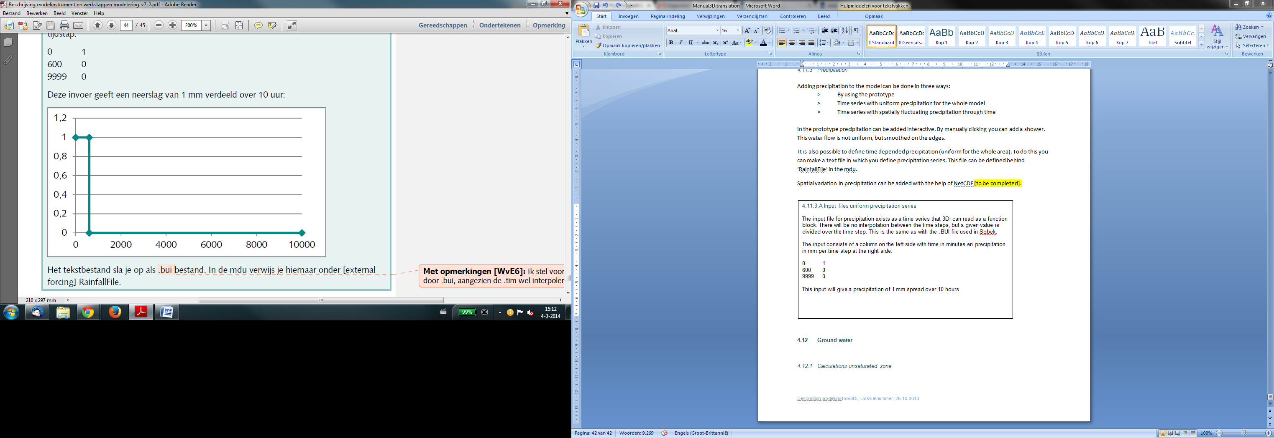

The text file must be saved as a .bui file. In the mdu you can refer to this file behind [external forcing] RainfallFile.

## 4.12 Ground water

## 

### 4.12.1 Calculations vadose zone

The vadose or unsaturated zoned consists of two parts; the root zone and the intermediate zone. However for the calculation only the mass balance is tracked with the assumption that the flux between the root zone and the saturated groundwater occurs directly. Therefore changes in the water content of the root zone as well as in the groundwater level are instantaneous. This assumption is not plausible in a situation where deep groundwater levels occur. Therefore a threshold is set, if this threshold is reached percolation will take place. Infiltrating water will then temporarily be buffered in the root zone. If the ground water content, defined at root zone +2 m depth, is reached the water will percolate from the root zone to the groundwater. This value can be found in UNSA_SIM.INP.

**Initial conditions**

The depth of the root zone is predefined for every crop type and soil type in the table ROOT_SIM.INP. Based on the depth of the root zone and the initial groundwater level, the initial water content can be calculated. At pF2 the ground is on field capacity. The initial water content will be calculated by looking at the water content when in balance in the table UNSA_SIM.INP at the right soil type, root depth and initial groundwater level. The value must be divided by root depth. Strangely enough not all root depths appear in UNSA_SIM.INP.

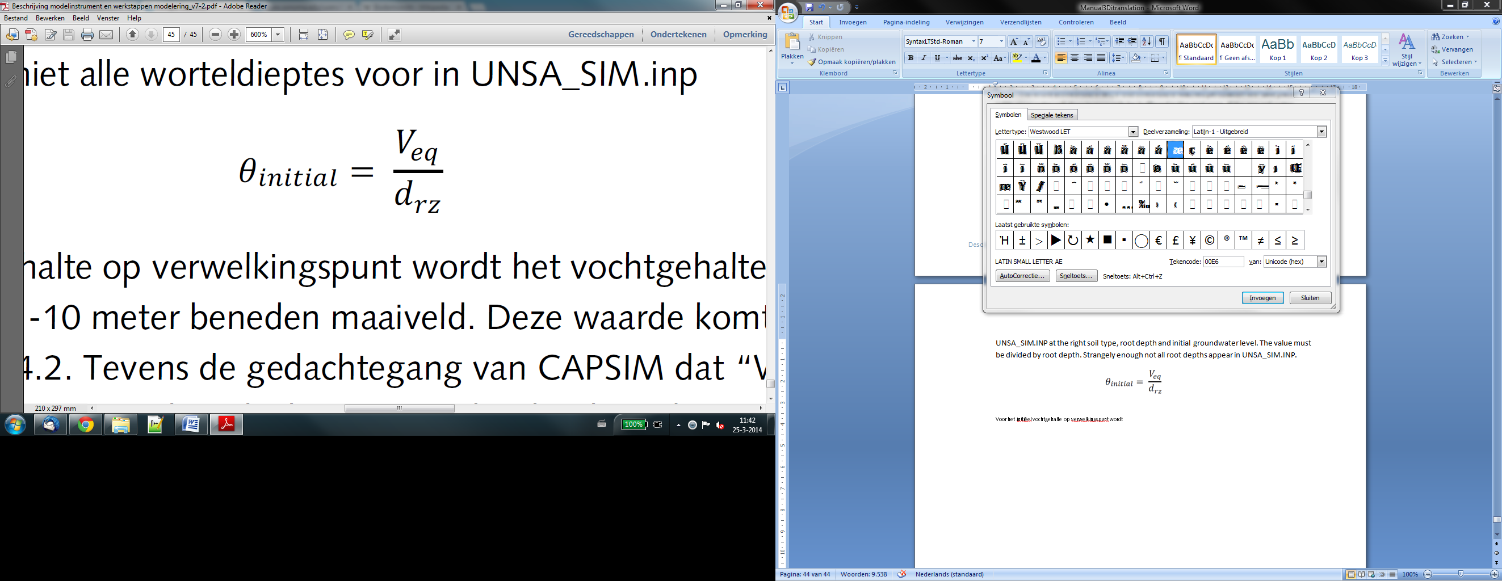

The water content for a groundwater level of -10 underneath the surface level is used for the initial water content on the wilting point. This value corresponds to pF3, hence not with pF 4.3. The reasoning of CAPSIM, that *“Water uptake by roots is zero at soil water pressure h4 which is assumed to be the wilting point”* implicates that the soil water content on the wilting point will be calculated by multiplying the value in balance with the parameter ‘h4’of the evaporation reduction curve, is also something that does not happen in 3Di.

If multiple values for the soil type occur within one quad cell the average will be calculated. The average water content in state of equilibrium will be determined by means of the fractions of the soil type on subgrid level. For determining the initial water content the model also calculates with the average root zone. When there are multiple crop types within one quad cell the same method is used.

The table UNSA_SIM.INP uses values per decimetre. Then how is the initial water level calculated when the root zone is in between two values. For example when there is a crop type 1 (grass) and soil type 14 (greenfield) the value for the root zone is 25 cm. The initial water content will be calculated at 20 cm when the soil water content is at equilibrium. In the equation as stated above a root zone of 25 cm will be used for calculations.

**Conclusions**

* Mass balance only in root zone.
* When groundwater is deeper than 2 meter + root zone, percolation occurs at soil water content of equilibrium 2m+rz.
* Not every root depth appears in UNSA_SIM.inp. When this is the case the shallowest value is used.
* Value wilting point is pF3, i.e. soil water content in equilibrium with the groundwater level 10 meters below surface level.
* When there are multiple soil types or crop types in a quad cell than the average will be determined by using fractions of the subgrid.

1. The model strives for a equilibrium between the continuity and momentum equation. This will be achieved by iterating within one time step. The equation will thus not be solved sequentially.